Shawn Wood

CMST 385 Principles of Web Design and Technology 1

06 OCT 2021

**FINAL PROJECT PROPOSAL**

**CMST385 | Shawn Wood**

**CLIENT & TOPIC**

I would like to create a website for option #5 : a website for a business someone else owns. I have a friend who is in the process of creating a business and I would like to assist his dream of attaining financial freedom. It will be a company that sells numerous products that help the user pass a drug screening.

**Development Process + Engagement DEVELOPMENT PROCESS**

The individual I am making the website for is actually one of my mentor’s I interact with almost every other day. I will create a storyboard and wireframe of my idea for the webpage. Then I will send these to him to get his perspective on what he would want and what he thinks would funnel more customers to purchasing a product.

**TESTING**

I will make sure every link/shortcut is valid and takes the customer to the proper webpage. Also make sure that everything fits properly in your standard webpage size, no bleeding into the sides. Of course, I will ask the client if they are satisfied with the product. I will include google chrome and microsoft edge in my testing.

**BUSINESS AND WEBSITE DESCRIPTION**

**Mission Statement**

To enable individuals to that consume marijuana for health benefits, to not be fired from their jobs for doing so.

**Goals**

This is a very small start-up that my friend and I will launch. The first year we want to expand and become profitable. First year goals are to:

* Create an additional source of revenue
* Obtain recurring clients
* Have products in 10 stores

**Target Audience**

The goal of the business is to create an affordable and profitable product for individuals who want to beat a drug screening. The website will outline our goals and what we can provide customers. It will also have a catalog of all the products we offer. The target audience is primarily individuals who smoke marijuana (an illicit substance) for health benefits, so they can continue using the medication with no repercussions.

**Impact of Target Audience on Design**

The website will be smoker friendly, images will be representative of what our target audience partakes in. Age demographic is for 18+

**Content**

I will use indesign to design a few images and browse the internet for images of the substance.

**Updates**

Updated anytime a new product comes out, company events, promotions, and any news advocating for federal legalization.

**GROWTH**

As the website attracts more customers, it will need to be able to host more active users on it. Some things you can do while developing the website is choosing an efficient web site builder, that not only looks good, but one that functions well. Make sure you keep the coding up to date, only in a perfect world there are no hackers looking to make a quick buck. Testing functionality of every button and link will need to be tested once a week.

**ORGANIZATION**

Below is a rough draft of how I plan on outlining the pages. The first one is a storyboard, It starts with everything connecting to the homepages. Then there are labels of what the page will be called then below is the contents of what will be on that page.

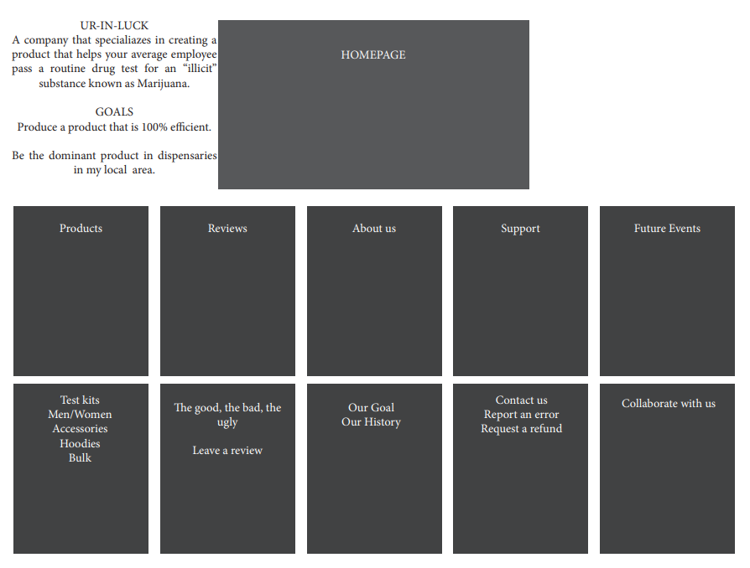 The next image is an idea of what the homepage will look like. Clickable boxes with images inside them that will take you to the next page.

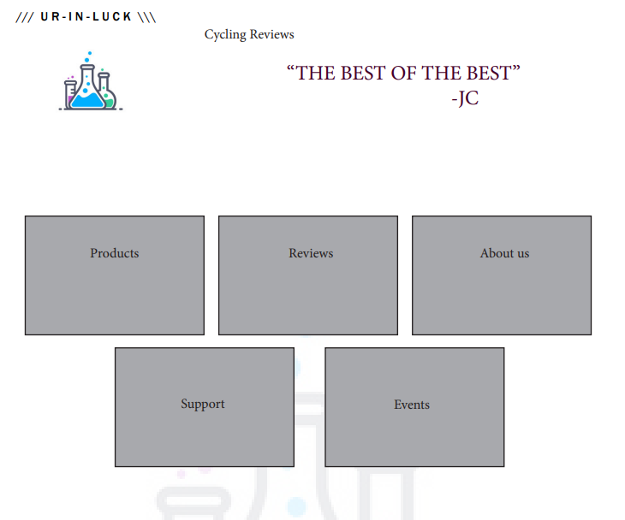

After clicking one of the boxes above you will be directed to the next page which will look like the photo below. Instead of boxes in the center the links will be at the type of page, allowing room for the contents to be displayed in the center.

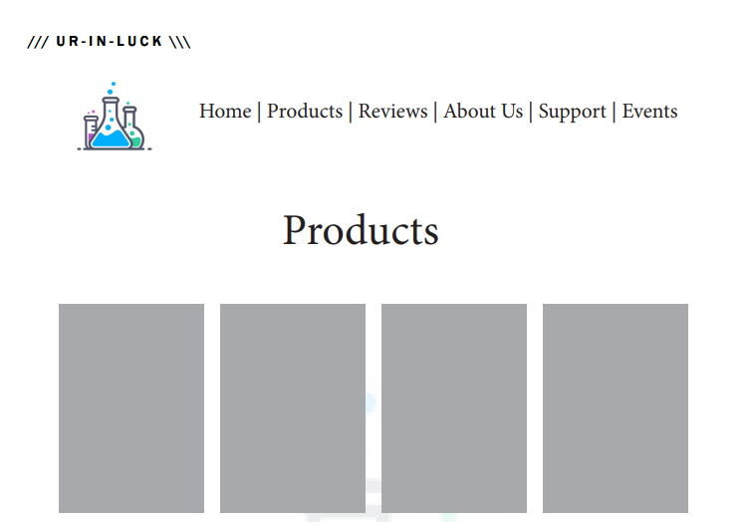

**WEB HOSTING**

When selecting a web host service there are some guidelines you need to follow to make sure you will be satisfied with your purchase. First the website needs to provide everything you will need in regards to technologies, databases, and do they have experience? Check their site and make sure they have details on troubleshooting, ticket systems, and issue resolution. Look for uptime guarantees of nearly 100%. Search for a comprehensive backend system that enables account control. Do some research and read reviews about web hosts, learn from others’ mistakes. Be sure to have a backup available in case anything goes wrong and you need to switch hosts. Purchase your own domain to ensure you have 100% control of your web page. The website will need to have a shopping cart implemented. The website will need to be able to support javascript. The web service I would choose would either be Bluehost or Hostgator. They have some of the best reviews and are moderately priced.

**MARKETING**

The website will be marketed by leaving business cards in local stores, implementing products in stores, and creating a social media platform. To improve SEO(search engine optimization) make sure the website is hosting quality, relevant, authoritative content. Learn your audience and figure out keywords they will search to find your product. Update your content often, you don’t want your customers to think the site is “dead”. Make sure you have optimal metadata that would hook onto the reader and pull them to the site. Create a link-worthy site, something that has keywords of what you are selling.

**SECURITY**

The website will have an e-commerce portion, you will be able to make purchases from the site. The content will be password protected if you want to have it remember your credit card information. There would also be an incentive program that would give you points that you could apply to your next purchase, so you would need to make an account. To maintain the security of your website make sure you are constantly updating to have the latest and greatest firewall. You should also have very strong passwords, make sure your site is hosted on it’s own server. I will not give the users any permissions to use other than purchasing and browsing products.

References

*Five ways to improve your site's ranking (SEO)*. Michigan Technological University. (n.d.). Retrieved October 7, 2021, from https://www.mtu.edu/umc/services/websites/seo/.

*Eight rules for choosing a web host*. Webcentral Blog. (2017, July 27). Retrieved October 7, 2021, from https://www.netregistry.com.au/blog/eight-rules-for-choosing-a-web-host/.

Escalona, A. (2016, June 1). *7 easy steps to maintain your website and increase traffic*. Lifehack. Retrieved October 7, 2021, from https://www.lifehack.org/406111/7-easy-steps-to-maintain-your-website-and-increase-traffic.

*Website security: How to secure & protect your website*. Sucuri. (2020, March 9). Retrieved October 7, 2021, from https://sucuri.net/guides/website-security/.